Figure 6
Connections over 200 kbps in at Least One Direction 2014-2018
(In thousands)

 | 2014 |  | 2015 |  | 2016 |  | 2017 |  | 2018
Technology | Jun* | Dec | Jun | Dec | Jun | Dec | Jun | Dec | Jun
Total | 324,471 | 338,202 | 357,613 | 375,895 | 395,604 | 404,971 | 408,816 | 420,973 | 428,983
Total Fixed | 95,982 | 98,245 | 100,179 | 102,216 | 104,088 | 105,715 | 106,254 | 108,200 | 109,207
Mobile Wireless | 228,489 | 239,957 | 257,434 | 273,679 | 291,516 | 299,256 | 302,562 | 312,773 | 319,776

Figure 7
Residential Connections over 200 kbps in at Least One Direction 2014-2018
(In thousands)

 | 2014 |  | 2015 |  | 2016 |  | 2017 |  | 2018
Technology | Jun* | Dec | Jun | Dec | Jun | Dec | Jun | Dec | Jun
Total | 277,551 | 290,696 | 306,292 | 322,557 | 330,987 | 337,978 | 341,094 | 351,964 | 358,851
Total Fixed | 87,345 | 89,530 | 91,439 | 93,434 | 95,001 | 96,607 | 97,072 | 98,843 | 99,742
Mobile Wireless | 190,205 | 201,166 | 214,853 | 229,122 | 235,985 | 241,371 | 244,022 | 253,121 | 259,109

* The June 2014 data have not been subjected to the typical quality checks (see Technical Notes).
Some previously published data may have been revised. Figures may not sum to totals due to rounding.

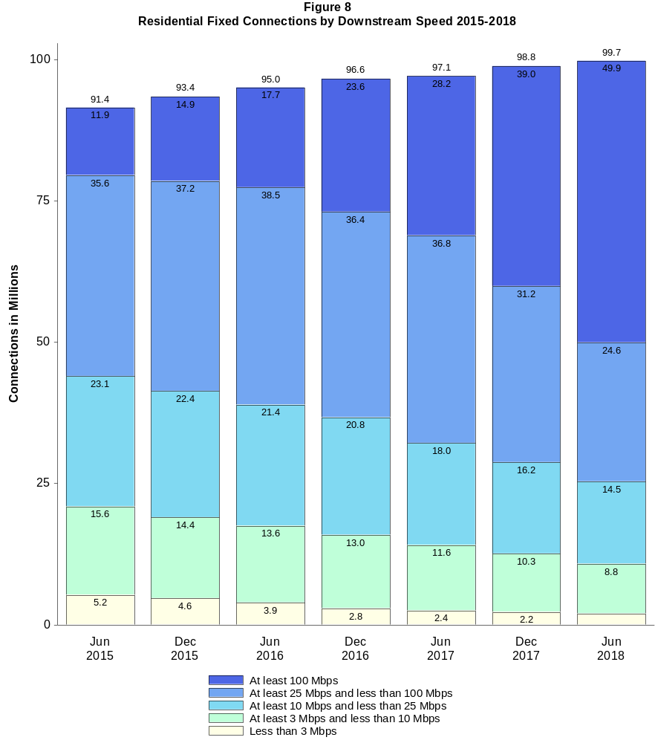

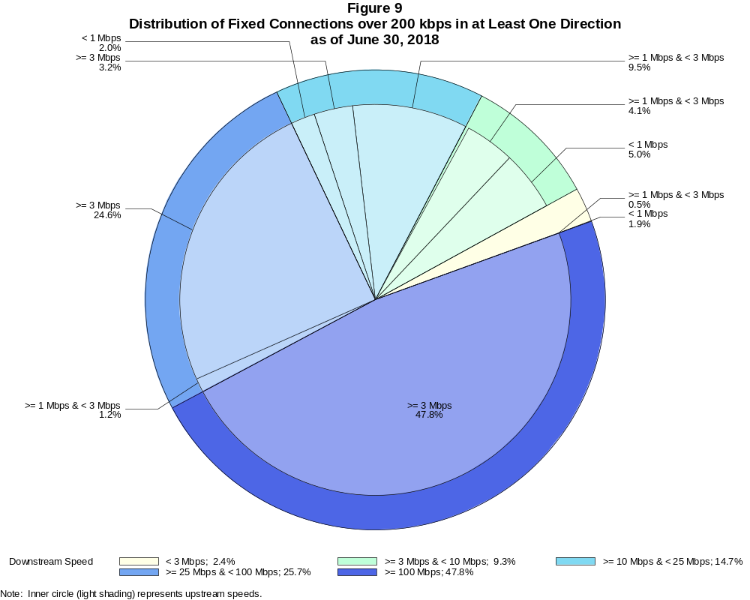

Fixed Connections over 200 kbps in at Least One Direction (in thousands)

 | Downstream Speed
Upstream Speed | Less than 3 Mbps | At least 3 Mbps  and less than 10 Mbps | At least 10 Mbps  and less than 25 Mbps | At least 25 Mbps  and less than 100 Mbps | At least 100 Mbps | Total
Less than 1 Mbps | 2,095 | 5,411 | 2,179 | # | # | 9,685
At least 1 Mbps & Less than 3 Mbps | 571 | 4,506 | 10,391 | 1,265 | 6 | 16,739
At least 3 Mbps | 3 | 293 | 3,492 | 26,832 | 52,162 | 82,783
Total | 2,669 | 10,210 | 16,062 | 28,098 | 52,168 | 109,207

Percentages

Less than 1 Mbps | 1.9 | 5.0 | 2.0 | 0.0 | 0.0 | 8.9
At least 1 Mbps & Less than 3 Mbps | 0.5 | 4.1 | 9.5 | 1.2 | 0.0 | 15.3
At least 3 Mbps | 0.0 | 0.3 | 3.2 | 24.6 | 47.8 | 75.8
Total | 2.4 | 9.3 | 14.7 | 25.7 | 47.8 | 100.0

Note: Figures may not sum to totals due to rounding. # = Rounds to zero.
Source: FCC Form 477.

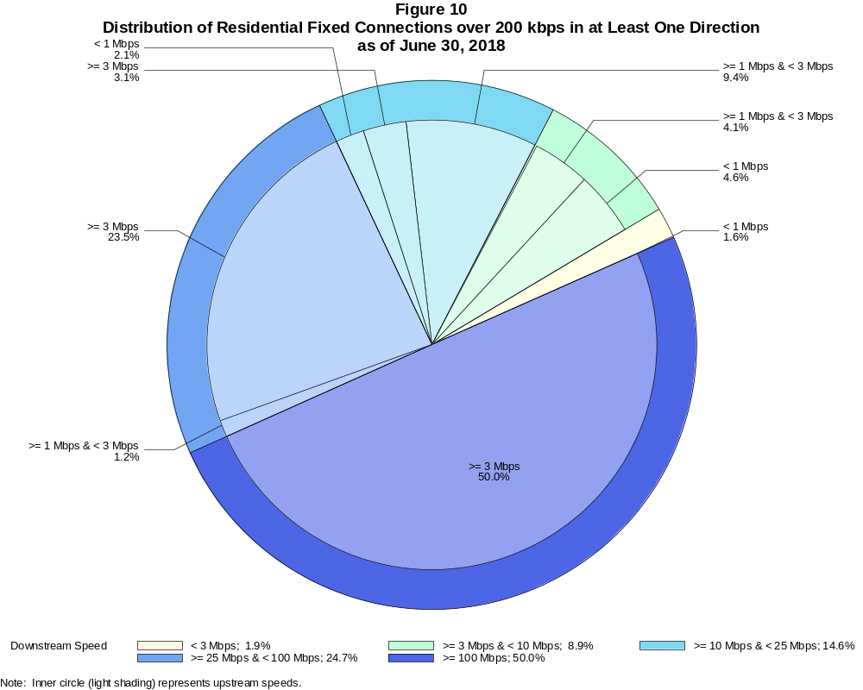

Residential Fixed Connections over 200 kbps in at Least One Direction (in thousands)

 | Downstream Speed
Upstream Speed | Less than 3 Mbps | At least 3 Mbps  and less than 10 Mbps | At least 10 Mbps  and less than 25 Mbps | At least 25 Mbps  and less than 100 Mbps | At least 100 Mbps | Total
Less than 1 Mbps | 1,610 | 4,563 | 2,047 | # | # | 8,219
At least 1 Mbps & Less than 3 Mbps | 292 | 4,119 | 9,380 | 1,201 | 5 | 14,998
At least 3 Mbps | 2 | 150 | 3,089 | 23,434 | 49,849 | 76,525
Total | 1,904 | 8,832 | 14,516 | 24,635 | 49,854 | 99,742

Percentages

Less than 1 Mbps | 1.6 | 4.6 | 2.1 | 0.0 | 0.0 | 8.2
At least 1 Mbps & Less than 3 Mbps | 0.3 | 4.1 | 9.4 | 1.2 | 0.0 | 15.0
At least 3 Mbps | 0.0 | 0.2 | 3.1 | 23.5 | 50.0 | 76.7
Total | 1.9 | 8.9 | 14.6 | 24.7 | 50.0 | 100.0

Note: Figures may not sum to totals due to rounding. # = Rounds to zero.
Source: FCC Form 477.

Figure 11
Connections over 200 kbps in at Least One Direction by Technology 2014-2018
(In thousands)

 | 2014 |  | 2015 |  | 2016 |  | 2017 |  | 2018
Technology | Jun* | Dec | Jun | Dec | Jun | Dec | Jun | Dec | Jun
Total | 324,471 | 338,202 | 357,613 | 375,895 | 395,604 | 404,971 | 408,816 | 420,973 | 428,983
Total Fixed | 95,982 | 98,245 | 100,179 | 102,216 | 104,088 | 105,715 | 106,254 | 108,200 | 109,207
aDSL | 29,870 | 29,533 | 29,351 | 28,134 | 27,488 | 26,527 | 25,506 | 24,193 | 23,072
sDSL | 96 | 72 | 77 | 60 | 55 | 42 | 44 | 28 | 28
Other Wireline¹ | 792 | 773 | 706 | 694 | 674 | 655 | 668 | 630 | 610
Cable Modem | 54,011 | 55,785 | 57,244 | 59,706 | 61,456 | 63,325 | 64,060 | 66,196 | 67,163
FTTP² | 8,312 | 9,077 | 9,688 | 10,498 | 11,143 | 12,053 | 12,906 | 13,978 | 14,982
Satellite | 1,964 | 2,006 | 2,058 | 2,071 | 2,079 | 1,864 | 1,826 | 1,872 | 1,939
Fixed Wireless | 935 | 999 | 1,056 | 1,054 | 1,192 | 1,250 | 1,245 | 1,304 | 1,414
Mobile Wireless | 228,489 | 239,957 | 257,434 | 273,679 | 291,516 | 299,256 | 302,562 | 312,773 | 319,776

¹ Power Line and Other are summarized with Other Wireline to maintain firm confidentiality. See Technical Notes at the end of the report for a description of
Form 477 technology categories and other reporting requirements.
² Fiber to the premises.
* The June 2014 data have not been subjected to the typical quality checks (see Technical Notes).
Some previously published data may have been revised. Figures may not sum to totals due to rounding.

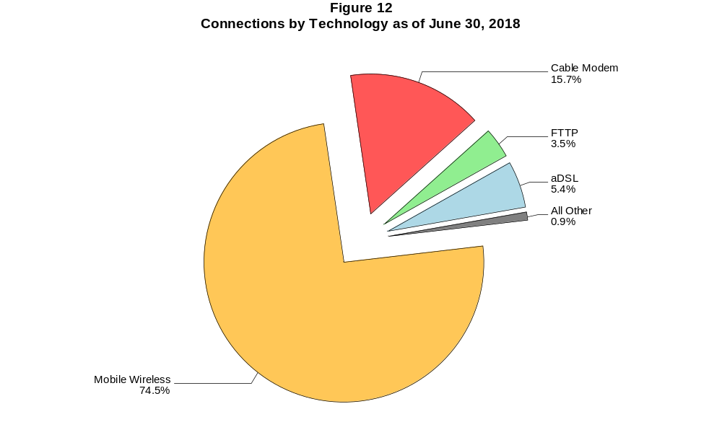

Figure 13
Residential Connections over 200 kbps in at Least One Direction by Technology 2014-2018
(In thousands)

 | 2014 |  | 2015 |  | 2016 |  | 2017 |  | 2018
Technology | Jun* | Dec | Jun | Dec | Jun | Dec | Jun | Dec | Jun
Total | 277,551 | 290,696 | 306,292 | 322,557 | 330,987 | 337,978 | 341,094 | 351,964 | 358,851
Total Fixed | 87,345 | 89,530 | 91,439 | 93,434 | 95,001 | 96,607 | 97,072 | 98,843 | 99,742
aDSL | 26,675 | 26,442 | 26,157 | 25,139 | 24,486 | 23,691 | 22,775 | 21,653 | 20,670
sDSL | 30 | 19 | 18 | 16 | 10 | 8 | 12 | 9 | 9
Other Wireline¹ | 57 | 59 | 59 | 54 | 51 | 32 | 74 | 67 | 74
Cable Modem | 50,389 | 52,061 | 53,544 | 55,799 | 57,358 | 59,145 | 59,687 | 61,567 | 62,318
FTTP² | 7,605 | 8,262 | 8,842 | 9,592 | 10,140 | 10,956 | 11,776 | 12,702 | 13,661
Satellite | 1,760 | 1,803 | 1,875 | 1,891 | 1,897 | 1,676 | 1,637 | 1,688 | 1,751
Fixed Wireless | 829 | 884 | 944 | 943 | 1,059 | 1,099 | 1,111 | 1,156 | 1,260
Mobile Wireless | 190,205 | 201,166 | 214,853 | 229,122 | 235,985 | 241,371 | 244,022 | 253,121 | 259,109

¹ Power Line and Other are summarized with Other Wireline to maintain firm confidentiality. See Technical Notes at the end of the report for a description of
Form 477 technology categories and other reporting requirements.
² Fiber to the premises.
* The June 2014 data have not been subjected to the typical quality checks (see Technical Notes).
Some previously published data may have been revised. Figures may not sum to totals due to rounding.

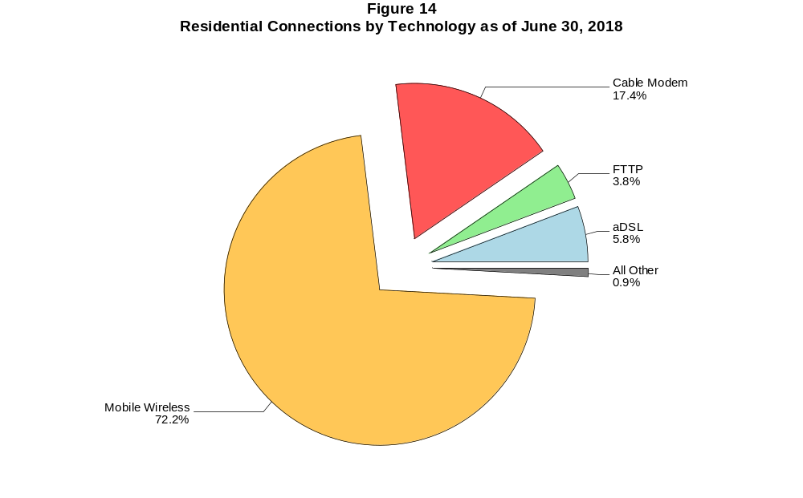

Figure 15
Fixed Connections at Least 3 Mbps Downstream and 768 kbps Upstream by Technology 2014-2018
(In thousands)

 | 2014 |  | 2015 |  | 2016 |  | 2017 |  | 2018
Technology | Jun* | Dec | Jun | Dec | Jun | Dec | Jun | Dec | Jun
Total | 78,981 | 83,872 | 89,011 | 92,356 | 95,517 | 98,761 | 100,098 | 102,047 | 104,054
aDSL | 17,246 | 18,557 | 20,947 | 20,744 | 21,147 | 21,042 | 20,621 | 19,257 | 18,874
sDSL | 33 | 28 | 24 | 20 | 20 | 20 | 24 | 16 | 17
Other Wireline¹ | 310 | 308 | 297 | 330 | 336 | 328 | 355 | 369 | 376
Cable Modem | 51,304 | 53,853 | 55,819 | 58,423 | 60,343 | 62,855 | 63,719 | 65,906 | 66,959
FTTP² | 8,111 | 8,974 | 9,552 | 10,383 | 11,030 | 11,953 | 12,813 | 13,870 | 14,889
Satellite | 1,424 | 1,558 | 1,690 | 1,744 | 1,775 | 1,609 | 1,586 | 1,563 | 1,722
Fixed Wireless | 553 | 594 | 681 | 712 | 865 | 954 | 981 | 1,065 | 1,216

¹ Power Line and Other are summarized with Other Wireline to maintain firm confidentiality. See Technical Notes at the end of the report for a description of Form
477 technology categories and other reporting requirements.
² Fiber to the premises.
* The June 2014 data have not been subjected to the typical quality checks (see Technical Notes).
# = Rounds to zero.
Some previously published data may have been revised. Figures may not sum to totals due to rounding.

Figure 16
Residential Fixed Connections at Least 3 Mbps Downstream and 768 kbps Upstream by Technology 2014-2018
(In thousands)

 | 2014 |  | 2015 |  | 2016 |  | 2017 |  | 2018
Technology | Jun* | Dec | Jun | Dec | Jun | Dec | Jun | Dec | Jun
Total | 73,042 | 77,540 | 82,320 | 85,439 | 88,198 | 91,258 | 92,355 | 93,987 | 95,741
aDSL | 15,673 | 16,867 | 18,988 | 18,866 | 19,207 | 19,133 | 18,719 | 17,480 | 17,127
sDSL | 7 | 2 | 1 | 2 | 2 | 2 | 7 | 6 | 6
Other Wireline¹ | 45 | 50 | 45 | 47 | 49 | 31 | 73 | 66 | 72
Cable Modem | 47,924 | 50,308 | 52,254 | 54,650 | 56,353 | 58,784 | 59,411 | 61,335 | 62,165
FTTP² | 7,491 | 8,246 | 8,750 | 9,512 | 10,063 | 10,883 | 11,704 | 12,616 | 13,588
Satellite | 1,419 | 1,552 | 1,682 | 1,734 | 1,764 | 1,596 | 1,571 | 1,545 | 1,700
Fixed Wireless | 483 | 516 | 599 | 628 | 759 | 830 | 870 | 940 | 1,082

¹ Power Line and Other are summarized with Other Wireline to maintain firm confidentiality. See Technical Notes at the end of the report for a description of Form
477 technology categories and other reporting requirements.
² Fiber to the premises.
* The June 2014 data have not been subjected to the typical quality checks (see Technical Notes).
# = Rounds to zero.
Some previously published data may have been revised. Figures may not sum to totals due to rounding.

Figure 17
Fixed Connections at Least 10 Mbps Downstream and 1 Mbps Upstream by Technology 2014-2018
(In thousands)

 | 2014 |  | 2015 |  | 2016 |  | 2017 |  | 2018
Technology | Jun* | Dec | Jun | Dec | Jun | Dec | Jun | Dec | Jun
Total | 63,823 | 68,238 | 72,713 | 76,939 | 80,458 | 84,112 | 86,967 | 90,703 | 94,148
aDSL | 7,561 | 8,560 | 9,471 | 9,799 | 10,349 | 10,810 | 11,321 | 11,595 | 11,817
sDSL | 9 | 6 | 9 | 8 | 8 | 10 | 14 | 9 | 11
Other Wireline¹ | 169 | 186 | 182 | 203 | 210 | 217 | 253 | 273 | 282
Cable Modem | 47,296 | 49,837 | 52,658 | 55,710 | 57,951 | 60,349 | 61,704 | 63,978 | 65,807
FTTP² | 7,601 | 8,320 | 8,874 | 9,575 | 10,143 | 11,001 | 11,884 | 12,954 | 13,988
Satellite | 1,016 | 1,136 | 1,298 | 1,393 | 1,467 | 1,342 | 1,373 | 1,402 | 1,595
Fixed Wireless | 170 | 193 | 221 | 252 | 330 | 383 | 418 | 492 | 649

¹ Power Line and Other are summarized with Other Wireline to maintain firm confidentiality. See Technical Notes at the end of the report for a description of
Form 477 technology categories and other reporting requirements.
² Fiber to the premises.
* The June 2014 data have not been subjected to the typical quality checks (see Technical Notes).
# = Rounds to zero.
Some previously published data may have been revised. Figures may not sum to totals due to rounding.

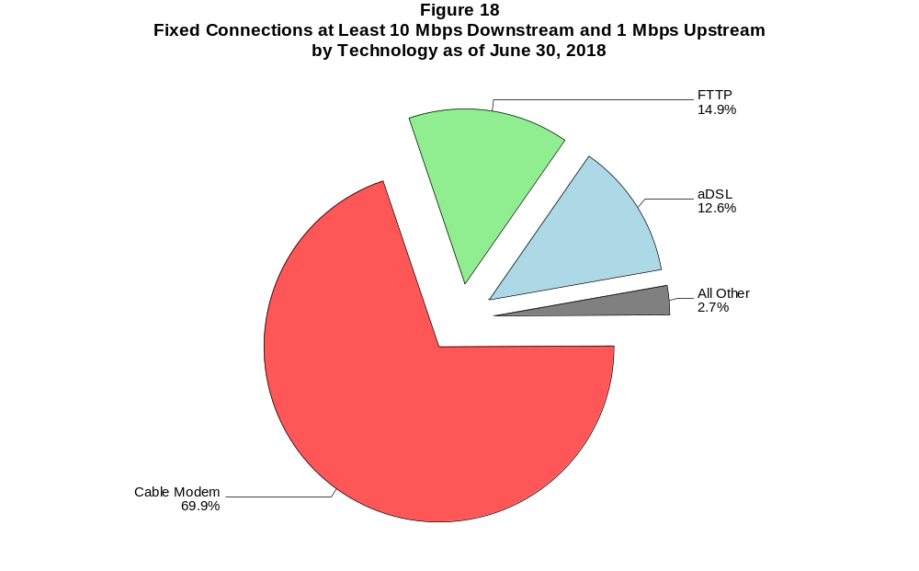

Figure 19
Residential Fixed Connections at Least 10 Mbps Downstream and 1 Mbps Upstream
by Technology 2014-2018
(In thousands)

 | 2014 |  | 2015 |  | 2016 |  | 2017 |  | 2018
Technology | Jun* | Dec | Jun | Dec | Jun | Dec | Jun | Dec | Jun
Total | 59,729 | 63,732 | 67,898 | 71,784 | 74,841 | 78,202 | 80,671 | 84,164 | 86,959
aDSL | 7,025 | 7,970 | 8,743 | 9,069 | 9,526 | 9,963 | 10,415 | 10,657 | 10,859
sDSL | 3 | # | # | 1 | 2 | 2 | 6 | 5 | 6
Other Wireline¹ | 33 | 36 | 38 | 43 | 47 | 30 | 71 | 64 | 65
Cable Modem | 44,480 | 46,772 | 49,487 | 52,294 | 54,274 | 56,538 | 57,617 | 59,864 | 61,141
FTTP² | 7,032 | 7,653 | 8,144 | 8,776 | 9,248 | 10,004 | 10,835 | 11,762 | 12,739
Satellite | 1,014 | 1,133 | 1,293 | 1,386 | 1,460 | 1,333 | 1,362 | 1,387 | 1,575
Fixed Wireless | 142 | 167 | 191 | 213 | 283 | 332 | 365 | 426 | 574

¹ Power Line and Other are summarized with Other Wireline to maintain firm confidentiality. See Technical Notes at the end of the report for a description of
Form 477 technology categories and other reporting requirements.
² Fiber to the premises.
* The June 2014 data have not been subjected to the typical quality checks (see Technical Notes).
# = Rounds to zero.
Some previously published data may have been revised. Figures may not sum to totals due to rounding.

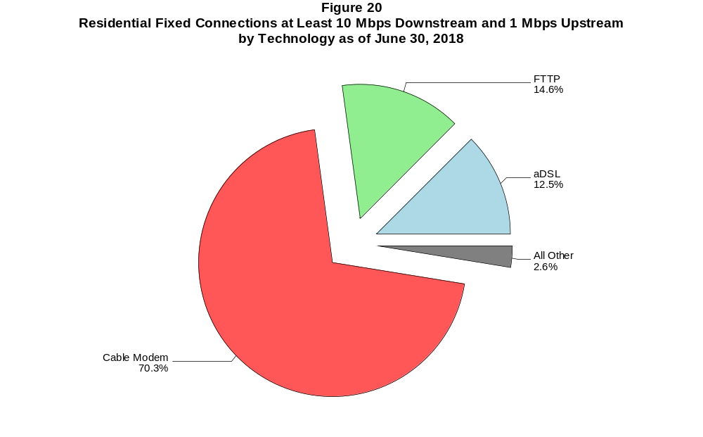

Figure 21
Fixed Connections at Least 25 Mbps Downstream and 3 Mbps Upstream by Technology 2014-2018
(In thousands)

 | 2014 |  | 2015 |  | 2016 |  | 2017 |  | 2018
Technology | Jun+ | Dec | Jun | Dec | Jun | Dec | Jun | Dec | Jun
Total | 35,924 | 42,713 | 48,784 | 54,335 | 58,753 | 62,907 | 68,041 | 73,331 | 78,175
aDSL | 421 | 587 | 762 | 938 | 1,239 | 1,476 | 2,530 | 3,586 | 4,297
sDSL | 2 | 1 | 1 | * | * | * | * | * | *
Other Wireline¹ | 114 | 125 | 125 | 141 | 158 | 170 | 207 | 224 | 209
Cable Modem | 30,769 | 36,383 | 40,979 | 45,530 | 48,696 | 51,740 | 54,829 | 57,870 | 60,858
FTTP² | 4,600 | 5,589 | 6,871 | 7,691 | 8,609 | 9,449 | 10,374 | 11,525 | 12,609
Satellite | # | # | # | * | * | * | * | * | *
Fixed Wireless | 19 | 28 | 47 | 55 | 72 | 92 | 120 | 146 | 222

¹ Power Line and Other are summarized with Other Wireline to maintain firm confidentiality. See Technical Notes at the end of the report for a description of
Form 477 technology categories and other reporting requirements.
² Fiber to the premises.
+ The June 2014 data have not been subjected to the typical quality checks (see Technical Notes).
* = Data withheld to maintain firm confidentiality.
# = Rounds to zero.
Some previously published data may have been revised. Figures may not sum to totals due to rounding.

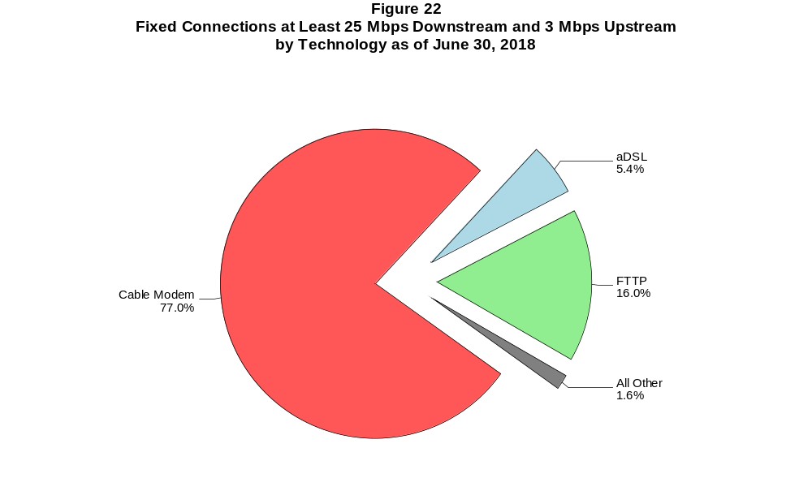

Figure 23
Residential Fixed Connections at Least 25 Mbps Downstream and 3 Mbps Upstream
by Technology 2014-2018
(In thousands)

 | 2014 |  | 2015 |  | 2016 |  | 2017 |  | 2018
Technology | Jun+ | Dec | Jun | Dec | Jun | Dec | Jun | Dec | Jun
Total | 34,437 | 40,916 | 46,532 | 51,788 | 55,694 | 59,463 | 64,253 | 68,871 | 72,480
aDSL | 397 | 556 | 727 | 897 | 1,173 | 1,408 | 2,418 | 3,410 | 4,067
sDSL | # | # | # | * | * | * | * | * | *
Other Wireline¹ | 22 | 26 | 26 | 31 | 41 | 27 | 67 | 59 | 54
Cable Modem | 29,806 | 35,202 | 39,416 | 43,746 | 46,527 | 49,300 | 52,154 | 54,748 | 56,619
FTTP² | 4,198 | 5,111 | 6,323 | 7,089 | 7,916 | 8,674 | 9,532 | 10,553 | 11,569
Satellite | 0 | 0 | 0 | * | * | * | * | * | *
Fixed Wireless | 14 | 22 | 40 | 46 | 57 | 75 | 101 | 121 | 192

¹ Power Line and Other are summarized with Other Wireline to maintain firm confidentiality. See Technical Notes at the end of the report for a description of
Form 477 technology categories and other reporting requirements.
² Fiber to the premises.
+ The June 2014 data have not been subjected to the typical quality checks (see Technical Notes).
* = Data withheld to maintain firm confidentiality.
# = Rounds to zero.
Some previously published data may have been revised. Figures may not sum to totals due to rounding.

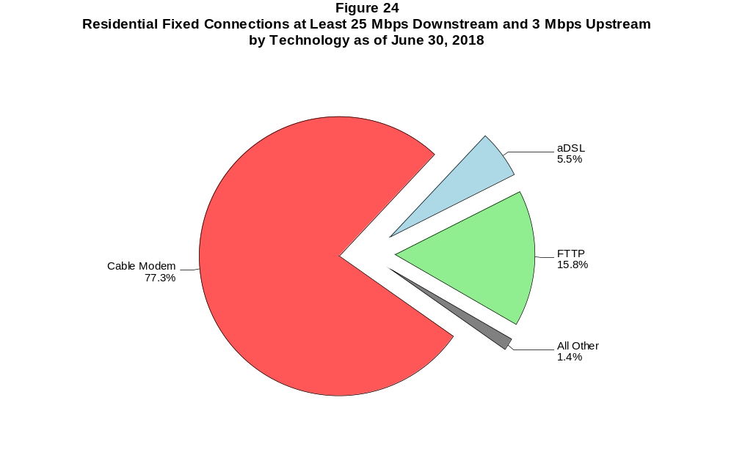

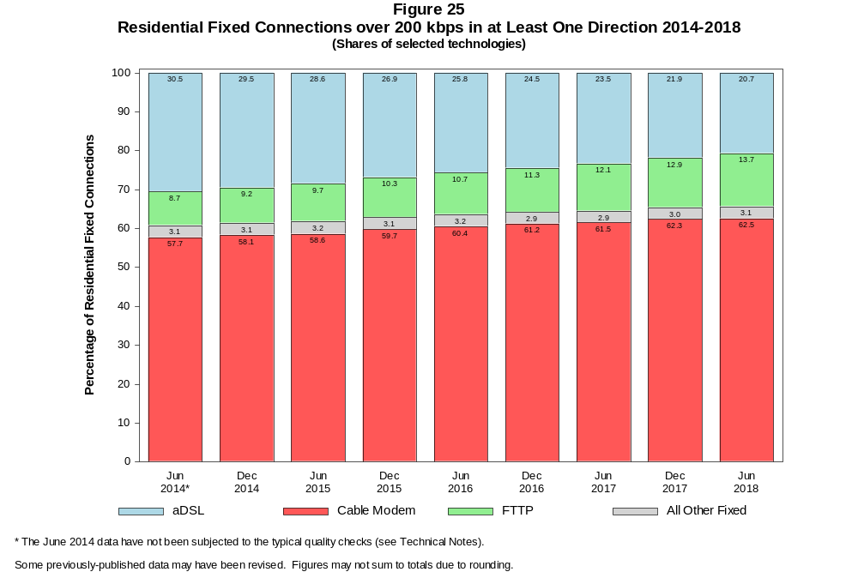

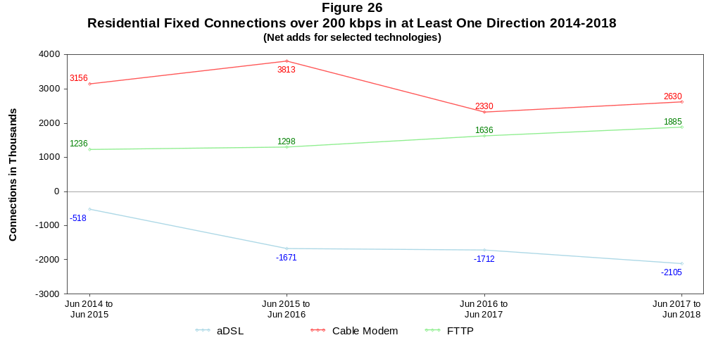

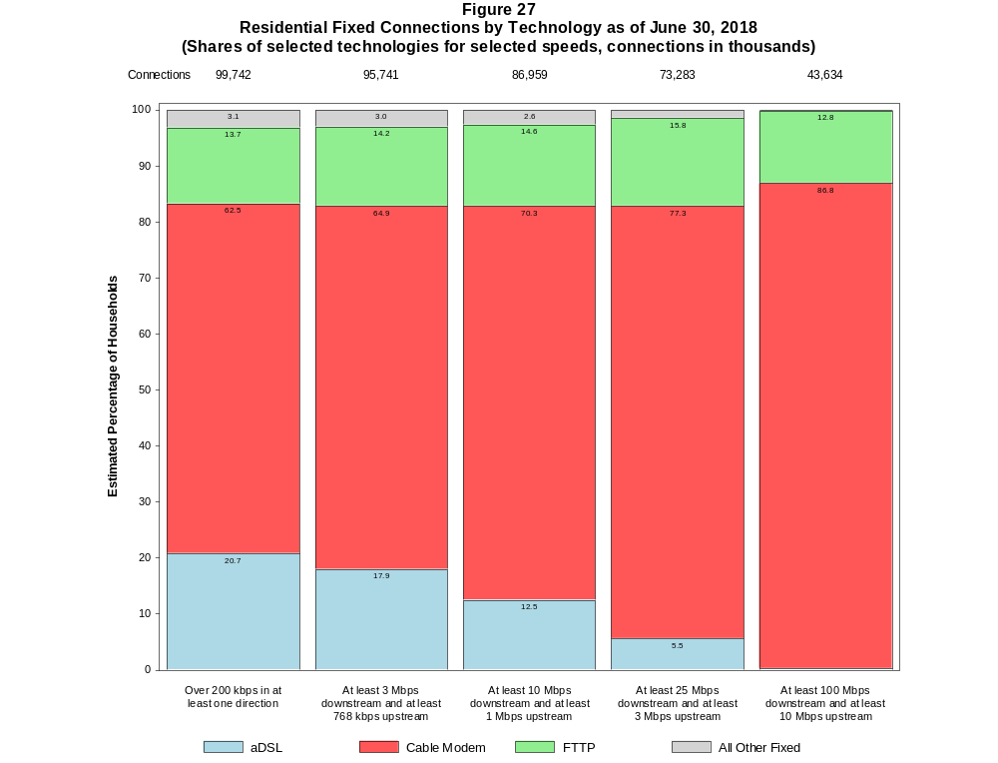

Figure 28
Fixed Connections by Downstream Speed Tier and Technology as of June 30, 2018
(In thousands)

 | Downstream Speed
Technology | Less than  1.5 Mbps | At least 1.5 Mbps  and less than  3 Mbps | At least 3 Mbps  and less than  10 Mbps | At least 10 Mbps  and less than  25 Mbps | At least 25 Mbps  and less than  100 Mbps | At least 100 Mbps | Total
aDSL | 638 | 1,242 | 7,564 | 8,768 | 4,749 | 111 | 23,072
sDSL | 5 | 6 | 6 | 7 | * | * | 28
Other Wireline¹ | 29 | 203 | 96 | 71 | 34 | 178 | 610
Cable Modem | 44 | 56 | 1,222 | 4,319 | 15,797 | 45,724 | 67,163
FTTP | 42 | 32 | 585 | 1,679 | 6,549 | 6,094 | 14,982
Satellite | 190 | 23 | 131 | 799 | * | * | 1,939
Fixed Wireless | 53 | 105 | 607 | 418 | 172 | 59 | 1,414
Total | 1,001 | 1,668 | 10,210 | 16,062 | 28,098 | 52,168 | 109,207

Percentages

aDSL | 0.6 | 1.1 | 6.9 | 8.0 | 4.3 | 0.1 | 21.1
sDSL | 0.0 | 0.0 | 0.0 | 0.0 | * | * | 0.0
Other Wireline¹ | 0.0 | 0.2 | 0.1 | 0.1 | 0.0 | 0.2 | 0.6
Cable Modem | 0.0 | 0.1 | 1.1 | 4.0 | 14.5 | 41.9 | 61.5
FTTP | 0.0 | 0.0 | 0.5 | 1.5 | 6.0 | 5.6 | 13.7
Satellite | 0.2 | 0.0 | 0.1 | 0.7 | * | * | 1.8
Fixed Wireless | 0.0 | 0.1 | 0.6 | 0.4 | 0.2 | 0.1 | 1.3
Total | 0.9 | 1.5 | 9.3 | 14.7 | 25.7 | 47.8 | 100.0

¹ Power Line and Other are summarized with Other Wireline to maintain firm confidentiality. See Technical Notes at the end of the report for a description of Form 477 technology categories
and other reporting requirements.
# = Rounds to Zero.
* = Data withheld to maintain firm confidentiality.
Note: Figures may not sum to totals due to rounding.
Source: FCC Form 477.

Figure 29
Residential Fixed Connections by Downstream Speed Tier and Technology as of June 30, 2018
(In thousands)

 | Downstream Speed
Technology | Less than  1.5 Mbps | At least 1.5 Mbps  and less than  3 Mbps | At least 3 Mbps  and less than  10 Mbps | At least 10 Mbps  and less than  25 Mbps | At least 25 Mbps  and less than  100 Mbps | At least 100 Mbps | Total
aDSL | 566 | 1,020 | 6,539 | 7,954 | 4,492 | 98 | 20,670
sDSL | 2 | 1 | 1 | 4 | * | * | 9
Other Wireline¹ | # | 1 | 7 | 11 | 9 | 46 | 74
Cable Modem | 38 | 29 | 1,078 | 3,909 | 13,207 | 44,057 | 62,318
FTTP | 32 | 25 | 536 | 1,470 | 5,996 | 5,602 | 13,661
Satellite | 42 | 7 | 126 | 794 | * | * | 1,751
Fixed Wireless | 46 | 94 | 546 | 375 | 149 | 50 | 1,260
Total | 726 | 1,178 | 8,832 | 14,516 | 24,635 | 49,854 | 99,742

Percentages

aDSL | 0.6 | 1.0 | 6.6 | 8.0 | 4.5 | 0.1 | 20.7
sDSL | 0.0 | 0.0 | 0.0 | 0.0 | * | * | 0.0
Other Wireline¹ | 0.0 | 0.0 | 0.0 | 0.0 | 0.0 | 0.0 | 0.1
Cable Modem | 0.0 | 0.0 | 1.1 | 3.9 | 13.2 | 44.2 | 62.5
FTTP | 0.0 | 0.0 | 0.5 | 1.5 | 6.0 | 5.6 | 13.7
Satellite | 0.0 | 0.0 | 0.1 | 0.8 | * | * | 1.8
Fixed Wireless | 0.0 | 0.1 | 0.5 | 0.4 | 0.1 | 0.1 | 1.3
Total | 0.7 | 1.2 | 8.9 | 14.6 | 24.7 | 50.0 | 100.0

¹ Power Line and Other are summarized with Other Wireline to maintain firm confidentiality. See Technical Notes at the end of the report for a description of Form 477 technology categories
and other reporting requirements.
# = Rounds to Zero.
* = Data withheld to maintain firm confidentiality.
Note: Figures may not sum to totals due to rounding.
Source: FCC Form 477.

Figure 30
Nationwide Number of Providers of Connections over 200 kbps in at Least One Direction
by Technology 2014-2018

 | 2014 |  | 2015 |  | 2016 |  | 2017 |  | 2018
Technology | Jun+ | Dec | Jun | Dec | Jun | Dec | Jun | Dec | Jun
aDSL | 793 | 793 | 792 | 778 | 769 | 774 | 769 | 743 | 738
sDSL | 192 | 187 | 177 | 180 | 171 | 160 | 161 | 150 | 136
Other Wireline¹ | 270 | 245 | 240 | 250 | 244 | 236 | 243 | 235 | 249
Cable Modem | 394 | 402 | 393 | 392 | 388 | 385 | 384 | 383 | 371
FTTP | 879 | 910 | 931 | 990 | 1,017 | 1,067 | 1,103 | 1,148 | 1,176
Satellite | 16 | 14 | 10 | 10 | 6 | 6 | 5 | 6 | 6
Fixed Wireless | 872 | 922 | 948 | 982 | 1,026 | 1,070 | 1,094 | 1,157 | 1,176
Mobile Wireless | 91 | 98 | 100 | 96 | 99 | 98 | 98 | 83 | 73
Power Line and Other¹ | - | - | - | - | - | - | - | - | -
Total | 1,816 | 1,872 | 1,881 | 1,917 | 1,956 | 2,000 | 2,030 | 2,087 | 2,113

¹ For this Figure, the categories Power Line and All Other were combined with Other Wireline.
+ The June 2014 data have not been subjected to the typical quality checks (see Technical Notes).
Multiple Form 477 filers within a holding company structure count as one provider. * = 1-3 providers.
Some previously published data may have been revised.

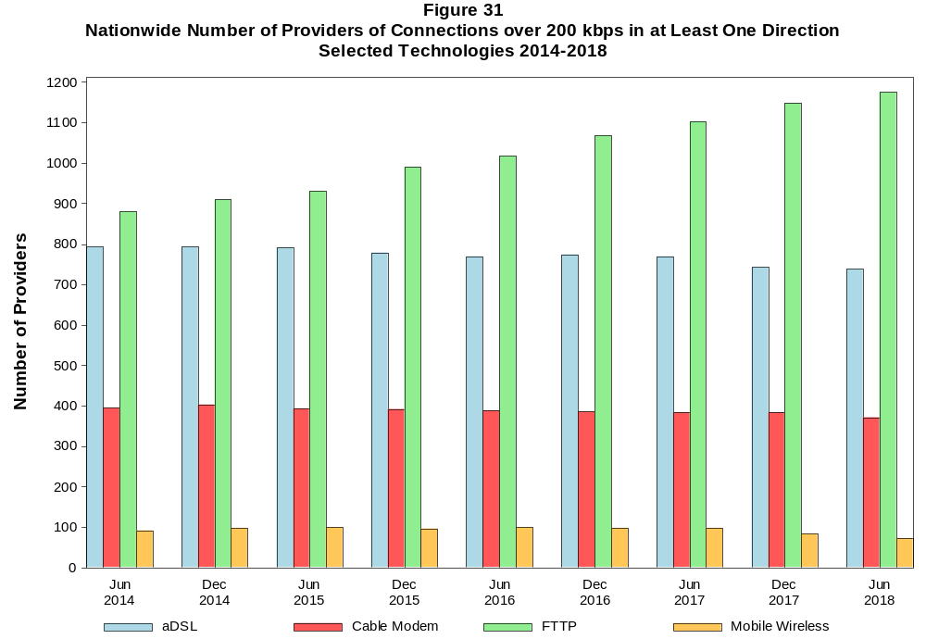

Figure 32
Residential Fixed Connections and Households by State as of June 30, 2018
(Connections and households, in thousands)

 |  | At least 200 kbps in  at least One Direction |  | At least 10 Mbps Down  and 1 Mbps Up |  | At least 25 Mbps Down  and 3 Mbps Up |  | At least 100 Mbps Down  and 10 Mbps Up
State | Households | Connections | Subscribership  Ratio | Connections | Subscribership  Ratio | Connections | Subscribership  Ratio | Connections | Subscribership  Ratio
Alabama | 1,860 | 1,351 | 0.73 | 1,099 | 0.59 | 850 | 0.46 | 477 | 0.26
Alaska | 253 | 201 | 0.79 | 166 | 0.65 | 123 | 0.48 | * | *
American Samoa | 10 | * | * | 0 | 0.00 | 0 | 0.00 | 0 | 0.00
Arizona | 2,524 | 2,116 | 0.84 | 1,753 | 0.69 | 1,505 | 0.60 | 1,007 | 0.40
Arkansas | 1,152 | 783 | 0.68 | 606 | 0.53 | 407 | 0.35 | 187 | 0.16
California | 12,965 | 11,331 | 0.87 | 10,241 | 0.79 | 8,678 | 0.67 | 5,173 | 0.40
Colorado | 2,113 | 1,897 | 0.90 | 1,555 | 0.74 | 1,415 | 0.67 | 602 | 0.28
Connecticut | 1,367 | 1,208 | 0.88 | 1,108 | 0.81 | 919 | 0.67 | 538 | 0.39
Delaware | 358 | 336 | 0.94 | 321 | 0.90 | 310 | 0.87 | 132 | 0.37
District of Columbia | 281 | 246 | 0.87 | 231 | 0.82 | 220 | 0.78 | * | *
Florida | 7,622 | 6,853 | 0.90 | 6,253 | 0.82 | 5,273 | 0.69 | 3,782 | 0.50
Georgia | 3,709 | 3,039 | 0.82 | 2,631 | 0.71 | 2,067 | 0.56 | 1,376 | 0.37
Guam | 42 | * | * | * | * | * | * | 0 | 0.00
Hawaii | 457 | 422 | 0.92 | 419 | 0.92 | * | * | * | *
Idaho | 618 | 508 | 0.82 | 331 | 0.54 | 256 | 0.41 | 60 | 0.10
Illinois | 4,830 | 3,853 | 0.80 | 3,400 | 0.70 | 2,693 | 0.56 | 1,849 | 0.38
Indiana | 2,554 | 1,951 | 0.76 | 1,630 | 0.64 | 1,266 | 0.50 | 870 | 0.34
Iowa | 1,257 | 949 | 0.76 | 700 | 0.56 | 572 | 0.45 | 222 | 0.18
Kansas | 1,125 | 888 | 0.79 | 738 | 0.66 | 548 | 0.49 | 355 | 0.32
Kentucky | 1,729 | 1,295 | 0.75 | 1,032 | 0.60 | 753 | 0.44 | 534 | 0.31
Louisiana | 1,736 | 1,280 | 0.74 | 1,096 | 0.63 | 846 | 0.49 | 529 | 0.30
Maine | 557 | 510 | 0.92 | 397 | 0.71 | 290 | 0.52 | 195 | 0.35
Maryland | 2,193 | 1,925 | 0.88 | 1,830 | 0.83 | 1,716 | 0.78 | 733 | 0.33
Massachusetts | 2,602 | 2,351 | 0.90 | 2,227 | 0.86 | 2,147 | 0.83 | 982 | 0.38
Michigan | 3,910 | 3,057 | 0.78 | 2,685 | 0.69 | 2,203 | 0.56 | 1,370 | 0.35
Minnesota | 2,168 | 1,756 | 0.81 | 1,397 | 0.64 | 1,217 | 0.56 | 512 | 0.24
Mississippi | 1,106 | 694 | 0.63 | 537 | 0.49 | 344 | 0.31 | 155 | 0.14
Missouri | 2,396 | 1,815 | 0.76 | 1,446 | 0.60 | 1,119 | 0.47 | 627 | 0.26
Montana | 423 | 336 | 0.79 | 249 | 0.59 | 210 | 0.50 | * | *
Nebraska | 754 | 589 | 0.78 | 481 | 0.64 | 392 | 0.52 | 275 | 0.36

Figure 32 - Continued
Residential Fixed Connections and Households by State as of June 30, 2018
(Connections and households, in thousands)

 |  | At least 200 kbps in  at least One Direction |  | At least 10 Mbps Down  and 1 Mbps Up |  | At least 25 Mbps Down  and 3 Mbps Up |  | At least 100 Mbps Down  and 10 Mbps Up
State | Households | Connections | Subscribership  Ratio | Connections | Subscribership  Ratio | Connections | Subscribership  Ratio | Connections | Subscribership  Ratio
Nevada | 1,076 | 927 | 0.86 | 834 | 0.78 | 703 | 0.65 | 516 | 0.48
New Hampshire | 528 | 498 | 0.94 | 442 | 0.84 | 401 | 0.76 | 176 | 0.33
New Jersey | 3,213 | 2,986 | 0.93 | 2,870 | 0.89 | 2,775 | 0.86 | 1,651 | 0.51
New Mexico | 776 | 568 | 0.73 | 382 | 0.49 | 319 | 0.41 | 100 | 0.13
New York | 7,317 | 6,334 | 0.87 | 5,971 | 0.82 | 5,511 | 0.75 | 4,034 | 0.55
North Carolina | 3,919 | 3,309 | 0.84 | 2,767 | 0.71 | 2,413 | 0.62 | 1,736 | 0.44
North Dakota | 315 | 256 | 0.81 | 232 | 0.74 | 205 | 0.65 | 152 | 0.48
Northern Mariana Isl | 16 | * | * | * | * | * | * | 0 | 0.00
Ohio | 4,654 | 3,707 | 0.80 | 3,184 | 0.68 | 2,409 | 0.52 | 1,554 | 0.33
Oklahoma | 1,475 | 1,043 | 0.71 | 829 | 0.56 | 621 | 0.42 | 369 | 0.25
Oregon | 1,592 | 1,330 | 0.84 | 1,117 | 0.70 | 994 | 0.62 | 415 | 0.26
Pennsylvania | 5,025 | 4,088 | 0.81 | 3,626 | 0.72 | 3,246 | 0.65 | 1,454 | 0.29
Puerto Rico | 1,205 | 592 | 0.49 | 299 | 0.25 | 213 | 0.18 | * | *
Rhode Island | 411 | 367 | 0.89 | 362 | 0.88 | 340 | 0.83 | * | *
South Carolina | 1,895 | 1,547 | 0.82 | 1,342 | 0.71 | 1,003 | 0.53 | 631 | 0.33
South Dakota | 342 | 266 | 0.78 | 238 | 0.70 | 212 | 0.62 | 142 | 0.42
Tennessee | 2,567 | 1,945 | 0.76 | 1,704 | 0.66 | 1,375 | 0.54 | 920 | 0.36
Texas | 9,553 | 7,695 | 0.81 | 6,793 | 0.71 | 5,442 | 0.57 | 3,187 | 0.33
Utah | 958 | 836 | 0.87 | 687 | 0.72 | 595 | 0.62 | 251 | 0.26
Vermont | 260 | 230 | 0.89 | 173 | 0.67 | 141 | 0.54 | 61 | 0.23
Virgin Islands | 43 | * | * | * | * | * | * | * | *
Virginia | 3,128 | 2,593 | 0.83 | 2,336 | 0.75 | 2,143 | 0.68 | 1,137 | 0.36
Washington | 2,800 | 2,457 | 0.88 | 2,099 | 0.75 | 1,902 | 0.68 | 880 | 0.31
West Virginia | 735 | 544 | 0.74 | 407 | 0.55 | 324 | 0.44 | 155 | 0.21
Wisconsin | 2,343 | 1,825 | 0.78 | 1,515 | 0.65 | 1,154 | 0.49 | 644 | 0.27
Wyoming | 231 | 180 | 0.78 | 139 | 0.60 | 120 | 0.52 | * | *
Total | 121,046 | 99,742 | 0.82 | 86,959 | 0.72 | 73,283 | 0.61 | 43,634 | 0.36

# = Rounds to Zero; * = Data withheld to maintain firm confidentiality.
Note: Figures may not sum to totals due to rounding.
Sources: FCC Form 477 (Connections); 2014-2018 ACS 5-year estimates; Census 2010.

Figure 33
Connections by Type of End User by State as of June 30, 2018
(Connections over 200 kbps in at least one direction, in thousands)

 | Connections |  | Percentages
State | Residential | Business | Residential | Business | Total
Alabama | 5,082 | 1,126 | 81.9 | 18.1 | 6,209
Alaska | 862 | 125 | 87.4 | 12.6 | 987
American Samoa | * | * | * | * | *
Arizona | 7,085 | 1,289 | 84.6 | 15.4 | 8,374
Arkansas | 2,838 | 760 | 78.9 | 21.1 | 3,597
California | 45,888 | 7,417 | 86.1 | 13.9 | 53,304
Colorado | 6,114 | 1,195 | 83.7 | 16.3 | 7,309
Connecticut | 4,031 | 911 | 81.6 | 18.4 | 4,942
Delaware | 1,058 | 200 | 84.1 | 15.9 | 1,259
District of Columbia | 950 | 509 | 65.1 | 34.9 | 1,458
Florida | 23,892 | 4,233 | 84.9 | 15.1 | 28,125
Georgia | 11,071 | 2,459 | 81.8 | 18.2 | 13,530
Guam | 183 | 49 | 79.0 | 21.0 | 232
Hawaii | 1,665 | 282 | 85.5 | 14.5 | 1,947
Idaho | 1,713 | 348 | 83.1 | 16.9 | 2,060
Illinois | 14,031 | 2,865 | 83.0 | 17.0 | 16,896
Indiana | 6,659 | 1,402 | 82.6 | 17.4 | 8,061
Iowa | 3,109 | 733 | 80.9 | 19.1 | 3,843
Kansas | 4,465 | 686 | 86.7 | 13.3 | 5,152
Kentucky | 4,757 | 791 | 85.7 | 14.3 | 5,547
Louisiana | 4,999 | 896 | 84.8 | 15.2 | 5,895
Maine | 1,394 | 404 | 77.5 | 22.5 | 1,798
Maryland | 6,924 | 1,219 | 85.0 | 15.0 | 8,143
Massachusetts | 8,226 | 1,534 | 84.3 | 15.7 | 9,760
Michigan | 10,445 | 2,374 | 81.5 | 18.5 | 12,819
Minnesota | 5,913 | 1,326 | 81.7 | 18.3 | 7,239
Mississippi | 2,960 | 542 | 84.5 | 15.5 | 3,502
Missouri | 6,282 | 1,339 | 82.4 | 17.6 | 7,621
Montana | 1,039 | 277 | 79.0 | 21.0 | 1,316
Nebraska | 1,855 | 532 | 77.7 | 22.3 | 2,387
Nevada | 3,271 | 550 | 85.6 | 14.4 | 3,822
New Hampshire | 1,464 | 349 | 80.8 | 19.2 | 1,812
New Jersey | 10,395 | 1,997 | 83.9 | 16.1 | 12,392
New Mexico | 2,058 | 369 | 84.8 | 15.2 | 2,426
New York | 23,922 | 4,260 | 84.9 | 15.1 | 28,181
North Carolina | 10,513 | 2,351 | 81.7 | 18.3 | 12,864
North Dakota | 796 | 209 | 79.2 | 20.8 | 1,005
Northern Mariana Isl | * | * | * | * | *
Ohio | 12,371 | 2,713 | 82.0 | 18.0 | 15,084
Oklahoma | 3,913 | 741 | 84.1 | 15.9 | 4,654
Oregon | 4,459 | 926 | 82.8 | 17.2 | 5,384
Pennsylvania | 13,772 | 2,819 | 83.0 | 17.0 | 16,591
Puerto Rico | 3,623 | 313 | 92.0 | 8.0 | 3,936
Rhode Island | 1,113 | 223 | 83.3 | 16.7 | 1,337
South Carolina | 5,005 | 1,098 | 82.0 | 18.0 | 6,103
South Dakota | 845 | 231 | 78.5 | 21.5 | 1,076
Tennessee | 6,886 | 1,613 | 81.0 | 19.0 | 8,499
Texas | 30,291 | 5,331 | 85.0 | 15.0 | 35,622
Utah | 2,982 | 610 | 83.0 | 17.0 | 3,592
Vermont | 658 | 173 | 79.2 | 20.8 | 831
Virgin Islands | 127 | 13 | 90.5 | 9.5 | 140
Virginia | 8,510 | 2,114 | 80.1 | 19.9 | 10,624
Washington | 8,272 | 1,579 | 84.0 | 16.0 | 9,851
West Virginia | 1,594 | 289 | 84.6 | 15.4 | 1,883
Wisconsin | 5,796 | 1,272 | 82.0 | 18.0 | 7,067
Wyoming | 619 | 149 | 80.6 | 19.4 | 768
Total | 358,851 | 70,132 | 83.7 | 16.3 | 428,983

# = Rounds to Zero.
* = Data withheld to maintain firm confidentiality.
Figures may not sum to totals due to rounding.
Source: FCC Form 477.

Figure 34
Connections by Technology by State as of June 30, 2018
(Connections over 200 kbps in at least one direction, in thousands)

State | ADSL | SDSL | Other  Wireline¹ | Cable  Modem | Fiber | Satellite | Fixed  Wireless | Mobile  Wireless | Total
Alabama | 481 | # | * | 791 | 134 | * | 6 | 4,728 | 6,209
Alaska | 77 | # | 2 | * | 5 | * | 9 | 752 | 987
American Samoa | * | * | 0 | * | * | 0 | * | * | *
Arizona | 530 | * | 12 | 1,505 | 156 | * | 44 | 6,092 | 8,374
Arkansas | 337 | # | * | 417 | 47 | * | 8 | 2,736 | 3,597
California | 2,940 | 3 | * | 8,006 | 1,155 | * | 122 | 40,865 | 53,304
Colorado | * | # | 18 | 1,299 | 218 | * | 74 | 5,240 | 7,309
Connecticut | * | * | 4 | 999 | 16 | * | # | 3,615 | 4,942
Delaware | * | * | 3 | 228 | * | * | * | 894 | 1,259
District of Columbia | * | * | 6 | * | * | * | * | 1,176 | 1,458
Florida | 1,496 | # | * | 4,963 | 892 | * | 18 | 20,639 | 28,125
Georgia | 947 | # | * | 1,883 | 416 | * | 5 | 10,192 | 13,530
Guam | * | 0 | 0 | * | * | 0 | 0 | 190 | 232
Hawaii | * | * | 1 | * | * | * | 2 | 1,491 | 1,947
Idaho | 168 | # | * | 224 | 90 | * | 51 | 1,506 | 2,060
Illinois | 1,142 | 1 | * | 2,721 | 204 | * | 83 | 12,672 | 16,896
Indiana | 614 | * | 6 | 1,157 | 247 | * | 42 | 5,944 | 8,061
Iowa | 272 | # | * | 484 | 204 | * | 44 | 2,804 | 3,843
Kansas | 239 | # | * | 472 | 191 | * | 40 | 4,186 | 5,152
Kentucky | 404 | * | 4 | 779 | 164 | * | 19 | 4,138 | 5,547
Louisiana | 399 | * | 5 | 823 | 121 | * | 6 | 4,485 | 5,895
Maine | 125 | 1 | * | 405 | 14 | * | 6 | 1,234 | 1,798
Maryland | * | # | 16 | 1,118 | * | * | 6 | 6,050 | 8,143
Massachusetts | * | # | 22 | 1,906 | * | * | 5 | 7,180 | 9,760
Michigan | 821 | 2 | * | 2,261 | 92 | * | 45 | 9,503 | 12,819
Minnesota | 473 | 2 | * | 1,146 | 223 | * | 31 | 5,326 | 7,239
Mississippi | 336 | # | * | 325 | 47 | * | 3 | 2,731 | 3,502
Missouri | 647 | # | * | 932 | 271 | * | 44 | 5,645 | 7,621
Montana | 99 | * | 2 | * | 30 | * | 23 | 939 | 1,316
Nebraska | 144 | # | * | 396 | 67 | * | 30 | 1,738 | 2,387

Figure 34 - Continued
Connections by Technology by State as of June 30, 2018
(Connections over 200 kbps in at least one direction, in thousands)

State | ADSL | SDSL | Other  Wireline¹ | Cable  Modem | Fiber | Satellite | Fixed  Wireless | Mobile  Wireless | Total
Nevada | 209 | # | 6 | * | 30 | * | 21 | 2,810 | 3,822
New Hampshire | 72 | # | * | 440 | 31 | * | 1 | 1,259 | 1,812
New Jersey | 146 | * | 27 | 2,116 | * | * | # | 9,097 | 12,392
New Mexico | 223 | # | * | 304 | 49 | * | 28 | 1,803 | 2,426
New York | 407 | * | 40 | 4,871 | 1,621 | * | 6 | 21,178 | 28,181
North Carolina | 799 | # | * | 2,327 | 382 | * | 8 | 9,266 | 12,864
North Dakota | 38 | 1 | * | 153 | 88 | * | 4 | 717 | 1,005
Northern Mariana Isl | * | * | * | * | * | 0 | 0 | * | *
Ohio | 1,010 | * | 13 | 2,621 | 278 | * | 46 | 11,065 | 15,084
Oklahoma | 363 | # | * | 591 | 91 | * | 50 | 3,502 | 4,654
Oregon | 234 | # | * | 966 | 191 | * | 26 | 3,926 | 5,384
Pennsylvania | 538 | # | 28 | 2,886 | * | * | 6 | 12,105 | 16,591
Puerto Rico | * | 0 | * | * | 7 | * | 10 | 3,280 | 3,936
Rhode Island | * | * | 2 | * | * | * | * | 936 | 1,337
South Carolina | 434 | # | * | 1,024 | 170 | * | 4 | 4,426 | 6,103
South Dakota | 42 | * | # | 173 | 63 | * | 10 | 781 | 1,076
Tennessee | 516 | # | * | 1,192 | 342 | * | 13 | 6,367 | 8,499
Texas | 2,133 | # | * | 4,400 | 1,407 | * | 225 | 27,205 | 35,622
Utah | 160 | # | * | 507 | 176 | * | 55 | 2,684 | 3,592
Vermont | 87 | * | 3 | 143 | 26 | * | 1 | 568 | 831
Virgin Islands | * | 0 | * | * | * | * | * | * | 140
Virginia | 284 | # | * | 1,506 | 921 | * | 18 | 7,781 | 10,624
Washington | 420 | # | * | 1,883 | 242 | * | 37 | 7,189 | 9,851
West Virginia | * | * | 1 | 367 | 11 | * | 3 | 1,285 | 1,883
Wisconsin | 602 | 7 | 5 | * | 126 | * | 34 | 5,079 | 7,067
Wyoming | 47 | * | 1 | 111 | 12 | * | 24 | 563 | 768
Total | 23,072 | 28 | 610 | 67,163 | 14,982 | 1,939 | 1,414 | 319,776 | 428,983

¹ Power Line and Other are summarized with Other Wireline to maintain firm confidentiality. See Technical Notes at the end of the report for a description of Form 477 technology categories and
other reporting requirements.
# = Rounds to Zero.
* = Data withheld to maintain firm confidentiality.
Figures may not sum to totals due to rounding.
Source: FCC Form 477.

Figure 35
Percentage of Fixed Connections by Downstream Speed by State as of June 30, 2018

 | Over 200 kbps Upstream and
State | % over 200 kbps  Downstream | % at least 3 Mbps  Downstream | % at least 10 Mbps  Downstream | % at least 25 Mbps  Downstream | % at least 100 Mbps  Downstream
Alabama | 99.6 | 95.7 | 83.1 | 64.2 | 35.3
Alaska | 98.6 | 93.2 | 80.9 | 58.8 | 42.3
American Samoa | * | * | * | * | *
Arizona | 99.8 | 97.7 | 90.8 | 70.9 | 49.9
Arkansas | 99.6 | 95.2 | 80.4 | 54.1 | 26.1
California | 99.8 | 98.1 | 89.1 | 74.9 | 51.2
Colorado | 99.8 | 96.9 | 90.5 | 74.4 | 47.6
Connecticut | 99.6 | 99.3 | 90.5 | 75.3 | 56.7
Delaware | 99.9 | 98.9 | 94.7 | 91.4 | 56.8
District of Columbia | 99.9 | 98.2 | 91.5 | 86.8 | 61.8
Florida | 99.7 | 98.3 | 92.8 | 79.2 | 52.6
Georgia | 99.4 | 97.0 | 86.9 | 70.1 | 43.3
Guam | * | * | * | * | *
Hawaii | 100.0 | 99.9 | 98.8 | 90.7 | 59.4
Idaho | 99.6 | 95.8 | 78.3 | 50.9 | 34.5
Illinois | 99.8 | 98.0 | 87.6 | 72.1 | 46.3
Indiana | 99.5 | 97.6 | 84.4 | 66.6 | 42.9
Iowa | 99.7 | 95.3 | 81.0 | 61.1 | 24.0
Kansas | 99.8 | 96.9 | 84.1 | 60.2 | 39.0
Kentucky | 99.3 | 95.9 | 80.5 | 59.2 | 39.9
Louisiana | 99.5 | 96.0 | 85.7 | 66.2 | 40.7
Maine | 99.2 | 94.3 | 76.9 | 56.1 | 38.7
Maryland | 99.9 | 98.7 | 93.7 | 88.2 | 52.1
Massachusetts | 99.9 | 98.7 | 93.6 | 90.2 | 60.8
Michigan | 99.5 | 97.9 | 87.4 | 73.6 | 42.9
Minnesota | 99.8 | 96.9 | 86.4 | 69.5 | 39.0
Mississippi | 99.3 | 94.1 | 77.8 | 53.0 | 29.5
Missouri | 99.6 | 96.2 | 83.1 | 62.4 | 36.5
Montana | 99.7 | 94.0 | 79.9 | 62.5 | 29.4
Nebraska | 99.7 | 97.2 | 85.0 | 66.5 | 45.5

Figure 35 - Continued
Percentage of Fixed Connections by Downstream Speed by State as of June 30, 2018

 | Over 200 kbps Upstream and
State | % over 200 kbps  Downstream | % at least 3 Mbps  Downstream | % at least 10 Mbps  Downstream | % at least 25 Mbps  Downstream | % at least 100 Mbps  Downstream
Nevada | 99.9 | 98.6 | 93.0 | 77.4 | 52.9
New Hampshire | 99.3 | 95.7 | 87.1 | 78.8 | 54.6
New Jersey | 99.8 | 98.8 | 95.4 | 91.9 | 64.6
New Mexico | 99.8 | 94.8 | 80.4 | 57.1 | 30.8
New York | 99.6 | 98.7 | 93.0 | 85.5 | 62.1
North Carolina | 99.4 | 97.2 | 86.5 | 72.4 | 51.5
North Dakota | 99.9 | 98.0 | 91.6 | 79.8 | 59.5
Northern Mariana Isl | * | * | * | * | *
Ohio | 99.8 | 97.7 | 86.0 | 64.8 | 41.7
Oklahoma | 99.7 | 97.1 | 79.9 | 58.5 | 36.8
Oregon | 99.8 | 97.1 | 88.9 | 75.1 | 45.7
Pennsylvania | 99.8 | 97.7 | 89.1 | 79.4 | 48.9
Puerto Rico | 99.9 | 87.0 | 53.3 | 34.8 | 13.2
Rhode Island | 99.7 | 98.9 | 97.5 | 91.1 | 58.3
South Carolina | 99.7 | 97.3 | 87.2 | 66.6 | 40.9
South Dakota | 99.7 | 97.9 | 90.8 | 79.3 | 50.3
Tennessee | 99.6 | 97.3 | 87.9 | 72.1 | 45.8
Texas | 99.8 | 98.1 | 88.1 | 70.1 | 45.6
Utah | 99.9 | 98.0 | 89.2 | 71.5 | 43.0
Vermont | 98.9 | 91.3 | 73.9 | 60.7 | 42.7
Virgin Islands | 99.9 | 98.9 | 62.0 | * | *
Virginia | 99.5 | 97.6 | 90.0 | 81.3 | 50.7
Washington | 99.6 | 97.3 | 89.9 | 77.2 | 54.1
West Virginia | 98.6 | 97.3 | 73.9 | 58.9 | 37.4
Wisconsin | 99.3 | 96.5 | 85.0 | 63.3 | 35.0
Wyoming | 99.7 | 94.5 | 81.7 | 65.5 | 25.1
Total | 99.7 | 97.6 | 88.2 | 73.5 | 47.8

Figure 36
Providers of Connections by Technology by State as of June 30, 2018
(Connections over 200 kbps in at least one direction, in thousands)

State | ADSL | SDSL | Other  Wireline¹ | Cable  Modem | Fiber | Satellite | Fixed  Wireless | Mobile  Wireless | Total
Alabama | 24 | 4 | * | 20 | 41 | * | 22 | 7 | 84
Alaska | 13 | 4 | 12 | * | 12 | * | 15 | 8 | 38
American Samoa | * | * | 0 | * | * | 0 | * | * | *
Arizona | 24 | * | 26 | 14 | 41 | * | 45 | 6 | 105
Arkansas | 24 | 4 | * | 21 | 40 | * | 21 | 5 | 81
California | 35 | 11 | * | 29 | 84 | * | 115 | 5 | 202
Colorado | * | 7 | 25 | 15 | 63 | * | 67 | 9 | 140
Connecticut | * | * | 14 | 8 | 20 | * | 7 | 4 | 38
Delaware | * | * | 9 | 6 | * | * | * | 4 | 26
District of Columbia | * | * | 12 | * | * | * | * | 4 | 37
Florida | 22 | 7 | * | 24 | 69 | * | 37 | 6 | 115
Georgia | 25 | 4 | * | 30 | 84 | * | 26 | 5 | 127
Guam | * | 0 | 0 | * | * | 0 | 0 | 4 | 4
Hawaii | * | * | 8 | * | * | * | 5 | 5 | 25
Idaho | 23 | 4 | * | 19 | 38 | * | 39 | 9 | 76
Illinois | 52 | 7 | * | 19 | 95 | * | 94 | 6 | 193
Indiana | 37 | * | 24 | 13 | 67 | * | 61 | 5 | 116
Iowa | 95 | 15 | * | 42 | 154 | * | 91 | 9 | 232
Kansas | 26 | 9 | * | 27 | 62 | * | 55 | 9 | 114
Kentucky | 19 | * | 12 | 28 | 43 | * | 31 | 8 | 97
Louisiana | 15 | * | 23 | 20 | 37 | * | 17 | 6 | 71
Maine | 12 | 6 | * | 9 | 18 | * | 9 | 5 | 37
Maryland | * | 5 | 18 | 15 | * | * | 18 | 5 | 69
Massachusetts | * | 4 | 17 | 10 | * | * | 23 | 5 | 66
Michigan | 33 | 8 | * | 25 | 66 | * | 49 | 6 | 130
Minnesota | 44 | 8 | * | 21 | 78 | * | 47 | 5 | 122
Mississippi | 18 | 4 | * | 15 | 28 | * | 13 | 6 | 59
Missouri | 36 | 9 | * | 17 | 68 | * | 72 | 7 | 144
Montana | 21 | * | 17 | * | 31 | * | 29 | 7 | 62
Nebraska | 31 | 4 | * | 21 | 55 | * | 50 | 7 | 106

Figure 36 - Continued
Providers of Connections by Technology by State as of June 30, 2018
(Connections over 200 kbps in at least one direction, in thousands)

State | ADSL | SDSL | Other  Wireline¹ | Cable  Modem | Fiber | Satellite | Fixed  Wireless | Mobile  Wireless | Total
Nevada | 15 | 7 | 17 | * | 32 | * | 26 | 5 | 71
New Hampshire | 9 | 5 | * | 5 | 20 | * | 5 | 6 | 34
New Jersey | 11 | * | 29 | 11 | * | * | 16 | 4 | 70
New Mexico | 19 | 5 | * | 10 | 30 | * | 34 | 8 | 71
New York | 33 | * | 30 | 20 | 65 | * | 30 | 7 | 113
North Carolina | 21 | 6 | * | 25 | 57 | * | 22 | 6 | 97
North Dakota | 22 | 8 | * | 9 | 31 | * | 14 | 6 | 47
Northern Mariana Isl | * | * | * | * | * | 0 | 0 | * | *
Ohio | 32 | * | 30 | 32 | 66 | * | 63 | 4 | 149
Oklahoma | 38 | 8 | * | 14 | 54 | * | 51 | 12 | 114
Oregon | 41 | 9 | * | 16 | 57 | * | 44 | 6 | 100
Pennsylvania | 25 | 6 | 25 | 25 | * | * | 26 | 8 | 105
Puerto Rico | * | 0 | * | * | 6 | * | 7 | 5 | 17
Rhode Island | * | * | 7 | * | * | * | * | 4 | 23
South Carolina | 18 | 4 | * | 17 | 34 | * | 16 | 6 | 56
South Dakota | 22 | * | 15 | 8 | 32 | * | 20 | 8 | 70
Tennessee | 22 | 4 | * | 23 | 61 | * | 36 | 7 | 114
Texas | 64 | 16 | * | 34 | 127 | * | 158 | 10 | 269
Utah | 18 | 4 | * | 12 | 28 | * | 34 | 9 | 71
Vermont | 10 | * | 6 | 6 | 19 | * | 4 | 6 | 31
Virgin Islands | * | 0 | * | * | * | * | * | * | 7
Virginia | 24 | 6 | * | 19 | 64 | * | 40 | 7 | 111
Washington | 26 | 6 | * | 22 | 61 | * | 52 | 6 | 113
West Virginia | * | * | 10 | 16 | 22 | * | 15 | 6 | 55
Wisconsin | 43 | 8 | 24 | * | 68 | * | 45 | 6 | 117
Wyoming | 14 | * | 11 | 7 | 17 | * | 26 | 8 | 50
Total | 738 | 136 | 249 | 371 | 1,176 | 6 | 1,176 | 73 | 2,113

¹ Power Line and Other are summarized with Other Wireline. See Technical Notes at the end of the report for a description of Form 477 technology categories and other reporting requirements.
# = Rounds to Zero.
* = Data withheld to maintain firm confidentiality.
Figures may not sum to totals due to rounding.
Source: FCC Form 477.
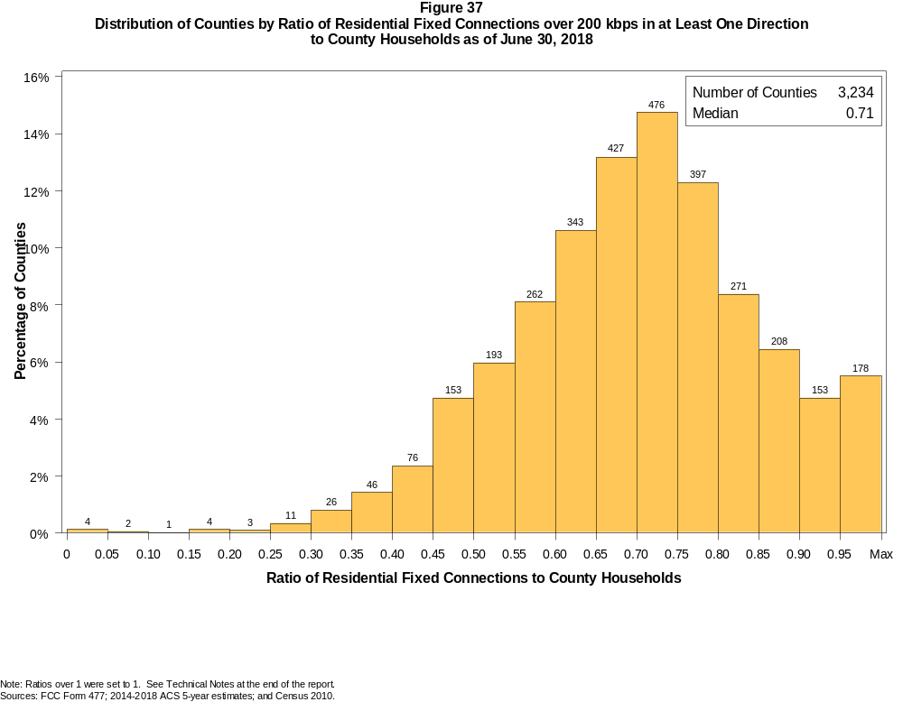

Figure 38
Distribution of Counties by Ratio of Residential Fixed Connections over 200 kbps in at Least One Direction
to County Households by Technology as of June 30, 2018

 | Ratio of Residential Fixed Connections to County Households
Technology | Zero | Greater than 0 and no more than 5% | Greater than 5 and no more than 10% | Greater than 10 and no more than 20% | Greater than 20 and no more than 30% | Greater than 30 and no more than 40% | Greater than 40 and no more than 50% | Greater than 50 and no more than 60% | Greater than 60 and no more than 80% | Greater than 80 and no more than 100% | 100% or more
aDSL | 1.3 | 6.4 | 8.1 | 28.4 | 28.6 | 15.6 | 7.2 | 2.7 | 1.4 | 0.2 | 0.2
sDSL | 93.8 | 6.0 | 0.2 | 0.1 | 0.0 | 0.0 | 0.0 | 0.0 | 0.0 | 0.0 | 0.0
Other Wireline | 91.9 | 7.7 | 0.2 | 0.0 | 0.1 | 0.0 | 0.0 | 0.0 | 0.0 | 0.0 | 0.0
Cable Modem | 11.7 | 6.3 | 6.1 | 14.1 | 14.1 | 13.0 | 12.1 | 12.4 | 8.6 | 1.2 | 0.4
FTTP | 23.7 | 42.4 | 9.6 | 9.8 | 4.9 | 3.2 | 2.4 | 1.9 | 1.9 | 0.2 | 0.0
Satellite | 1.1 | 65.0 | 22.6 | 10.0 | 1.0 | 0.2 | 0.0 | 0.0 | 0.0 | 0.0 | 0.0
Fixed Wireless | 20.4 | 56.8 | 11.9 | 7.5 | 2.1 | 0.8 | 0.3 | 0.0 | 0.1 | 0.0 | 0.1
Total | 0.1 | 0.0 | 0.1 | 0.2 | 0.4 | 2.2 | 7.1 | 14.1 | 50.8 | 21.5 | 3.6

¹ Power Line and Other are summarized with Other Wireline. See Technical Notes at the end of the report for a description of Form 477 technology categories and other reporting requirements.
Note: Figures may not sum to totals due to rounding.
Sources: FCC Form 477; 2014-2018 ACS 5-year estimates; and Census 2010.

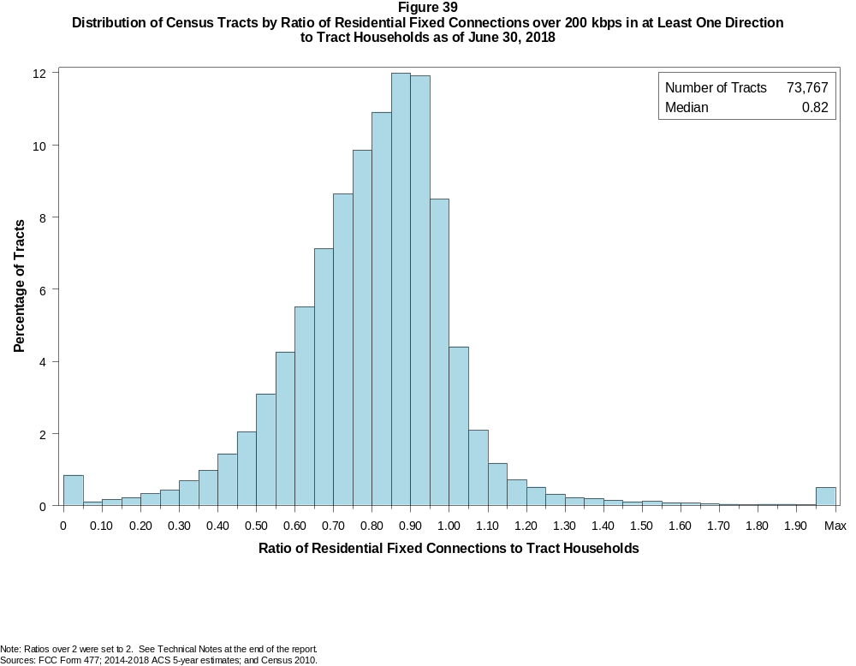

Figure 40
Distribution of Census Tracts by Ratio of Residential Fixed Connections over 200 kbps in at Least One Direction
to Tract Households by Technology as of June 30, 2018

 | Ratio of Residential Fixed Connections to Tract Households
Technology | Zero | Greater than 0 and no more than 5% | Greater than 5 and no more than 10% | Greater than 10 and no more than 20% | Greater than 20 and no more than 30% | Greater than 30 and no more than 40% | Greater than 40 and no more than 50% | Greater than 50 and no more than 60% | Greater than 60 and no more than 80% | Greater than 80 and no more than 100% | 100% or more
aDSL | 2.6 | 22.3 | 14.2 | 25.4 | 18.4 | 10.0 | 4.1 | 1.6 | 0.9 | 0.2 | 0.2
sDSL | 99.2 | 0.8 | 0.0 | 0.0 | 0.0 | 0.0 | 0.0 | 0.0 | 0.0 | 0.0 | 0.0
Other Wireline | 98.7 | 1.0 | 0.1 | 0.1 | 0.0 | 0.0 | 0.0 | 0.0 | 0.0 | 0.0 | 0.0
Cable Modem | 4.7 | 2.7 | 1.7 | 3.9 | 6.3 | 11.6 | 16.9 | 19.4 | 24.5 | 6.6 | 1.7
FTTP | 41.5 | 20.3 | 6.9 | 10.1 | 6.4 | 5.4 | 4.2 | 2.7 | 2.1 | 0.3 | 0.1
Satellite | 35.4 | 54.9 | 5.1 | 3.2 | 0.9 | 0.3 | 0.1 | 0.0 | 0.0 | 0.0 | 0.0
Fixed Wireless | 72.8 | 20.9 | 2.7 | 2.2 | 0.8 | 0.3 | 0.1 | 0.1 | 0.0 | 0.0 | 0.0
Total | 0.8 | 0.1 | 0.1 | 0.4 | 0.8 | 1.7 | 3.5 | 7.3 | 31.2 | 43.4 | 10.8

¹ Power Line and Other are summarized with Other Wireline. See Technical Notes at the end of the report for a description of Form 477 technology categories and other reporting requirements.
Note: Figures may not sum to totals due to rounding.
Sources: FCC Form 477; 2014-2018 ACS 5-year estimates; and Census 2010.

Figure 41
Percentage of Developed Census Blocks with Residential Fixed Service by Technology as of June 30, 2018
(Internet Access Service over 200 kbps in at least one direction)

 | Number of Providers
Technology | Zero | One | Two | Three | Four | Five | Six | Seven or More
aDSL | 24.0 | 73.2 | 2.7 | 0.1 | 0.0 | 0.0 | 0.0 | 0.0
sDSL | 99.4 | 0.6 | 0.0 | 0.0 | 0.0 | 0.0 | 0.0 | 0.0
Other Wireline¹ | 99.0 | 1.0 | 0.0 | 0.0 | 0.0 | 0.0 | 0.0 | 0.0
Cable Modem | 66.9 | 31.5 | 1.5 | 0.0 | 0.0 | 0.0 | 0.0 | 0.0
FTTP | 77.8 | 21.4 | 0.8 | 0.0 | 0.0 | 0.0 | 0.0 | 0.0
Satellite | 0.0 | 0.1 | 0.9 | 98.9 | 0.0 | 0.0 | 0.0 | 0.0
Fixed Wireless | 59.6 | 26.8 | 9.9 | 3.3 | 0.5 | 0.0 | 0.0 | 0.0
aDSL and/or Cable Modem and/or FTTP | 14.3 | 52.0 | 29.7 | 3.8 | 0.2 | 0.0 | 0.0 | 0.0
Any Technology | 0.0 | 0.1 | 0.2 | 5.7 | 18.4 | 43.7 | 21.8 | 10.2

¹ Power Line and Other are summarized with Other Wireline. See Technical Notes at the end of the report for a description of Form 477 technology categories and other reporting requirements.
Note: Figures may not sum to totals due to rounding. The number of providers in a census block does not necessarily reflect the number of choices available to a particular household, and does not
purport to measure competition. Providers may list a census block on Form 477 if service can be provided to at least one location in the block. Developed census blocks are those with housing units
based on the 2010 census.
Sources: FCC Form 477 and Census 2010.

Figure 42
Distribution of Counties by Ratio of Residential Fixed Connections to County Households by State as of June 30, 2018
(Connections over 200 kbps in at least one direction)

 |  | Ratio of Residential Fixed Connections over 200 kbps in at Least One Direction to County Households
State | Counties | Zero | Greater than 0 and no more than 5% | Greater than 5 and no more than 10% | Greater than 10 and no more than 20% | Greater than 20 and no more than 30% | Greater than 30 and no more than 40% | Greater than 40 and no more than 50% | Greater than 50 and no more than 60% | Greater than 60 and no more than 80% | Greater than 80 and no more than 100% | 100% or more
Alabama | 67 | 0 | 0 | 0 | 0 | 0 | 3 | 11 | 18 | 29 | 6 | 0
Alaska | 29 | 0 | 0 | 0 | 1 | 0 | 2 | 4 | 0 | 10 | 9 | 3
American Samoa | 5 | 2 | 0 | 0 | 0 | 1 | 1 | 1 | 0 | 0 | 0 | 0
Arizona | 15 | 0 | 0 | 0 | 0 | 0 | 0 | 0 | 2 | 7 | 6 | 0
Arkansas | 75 | 0 | 0 | 0 | 0 | 0 | 3 | 20 | 28 | 22 | 2 | 0
California | 58 | 0 | 0 | 0 | 0 | 0 | 0 | 0 | 0 | 18 | 37 | 3
Colorado | 64 | 0 | 0 | 0 | 0 | 0 | 1 | 2 | 5 | 21 | 22 | 13
Connecticut | 8 | 0 | 0 | 0 | 0 | 0 | 0 | 0 | 0 | 0 | 8 | 0
Delaware | 3 | 0 | 0 | 0 | 0 | 0 | 0 | 0 | 0 | 0 | 2 | 1
District of Columbia | 1 | 0 | 0 | 0 | 0 | 0 | 0 | 0 | 0 | 0 | 1 | 0
Florida | 67 | 0 | 0 | 0 | 0 | 0 | 0 | 0 | 7 | 19 | 31 | 10
Georgia | 159 | 0 | 0 | 0 | 1 | 2 | 7 | 17 | 32 | 59 | 35 | 6
Guam | 1 | 0 | 0 | 0 | 0 | 0 | 0 | 0 | 0 | 0 | 1 | 0
Hawaii | 5 | 1 | 0 | 0 | 0 | 0 | 0 | 0 | 0 | 1 | 1 | 2
Idaho | 44 | 0 | 0 | 0 | 0 | 0 | 0 | 0 | 2 | 25 | 13 | 4
Illinois | 102 | 0 | 0 | 0 | 0 | 0 | 1 | 3 | 15 | 69 | 14 | 0
Indiana | 92 | 0 | 0 | 0 | 0 | 0 | 0 | 1 | 15 | 65 | 11 | 0
Iowa | 99 | 0 | 0 | 0 | 0 | 0 | 0 | 1 | 9 | 83 | 5 | 1
Kansas | 105 | 0 | 0 | 0 | 0 | 0 | 1 | 2 | 11 | 76 | 15 | 0
Kentucky | 120 | 0 | 0 | 0 | 0 | 1 | 1 | 10 | 19 | 75 | 14 | 0
Louisiana | 64 | 0 | 0 | 0 | 0 | 0 | 4 | 11 | 14 | 28 | 7 | 0
Maine | 16 | 0 | 0 | 0 | 0 | 0 | 0 | 0 | 0 | 5 | 6 | 5
Maryland | 24 | 0 | 0 | 0 | 0 | 0 | 0 | 0 | 1 | 8 | 14 | 1
Massachusetts | 14 | 0 | 0 | 0 | 0 | 0 | 0 | 0 | 0 | 1 | 10 | 3
Michigan | 83 | 0 | 0 | 0 | 0 | 0 | 0 | 3 | 7 | 53 | 16 | 4
Minnesota | 87 | 0 | 0 | 0 | 1 | 0 | 0 | 0 | 2 | 61 | 22 | 1
Mississippi | 82 | 0 | 0 | 0 | 1 | 0 | 11 | 27 | 26 | 13 | 4 | 0
Missouri | 115 | 0 | 0 | 0 | 0 | 1 | 2 | 16 | 25 | 59 | 11 | 1
Montana | 56 | 0 | 0 | 0 | 0 | 0 | 0 | 3 | 4 | 32 | 15 | 2
Nebraska | 93 | 0 | 0 | 0 | 0 | 0 | 2 | 7 | 13 | 68 | 3 | 0

Figure 42 - Continued
Distribution of Counties by Ratio of Residential Fixed Connections to County Households by State as of June 30, 2018
(Connections over 200 kbps in at least one direction)

 |  | Ratio of Residential Fixed Connections over 200 kbps in at Least One Direction to County Households
State | Counties | Zero | Greater than 0 and no more than 5% | Greater than 5 and no more than 10% | Greater than 10 and no more than 20% | Greater than 20 and no more than 30% | Greater than 30 and no more than 40% | Greater than 40 and no more than 50% | Greater than 50 and no more than 60% | Greater than 60 and no more than 80% | Greater than 80 and no more than 100% | 100% or more
Nevada | 17 | 0 | 0 | 0 | 0 | 1 | 0 | 1 | 2 | 9 | 4 | 0
New Hampshire | 10 | 0 | 0 | 0 | 0 | 0 | 0 | 0 | 0 | 0 | 7 | 3
New Jersey | 21 | 0 | 0 | 0 | 0 | 0 | 0 | 0 | 0 | 0 | 19 | 2
New Mexico | 33 | 0 | 0 | 2 | 0 | 2 | 0 | 2 | 6 | 17 | 3 | 1
New York | 62 | 0 | 0 | 0 | 0 | 0 | 0 | 0 | 0 | 31 | 27 | 4
North Carolina | 100 | 0 | 0 | 0 | 0 | 0 | 0 | 1 | 11 | 47 | 34 | 7
North Dakota | 53 | 0 | 0 | 0 | 0 | 0 | 0 | 0 | 3 | 34 | 15 | 1
Northern Mariana Isl | 4 | 1 | 0 | 0 | 0 | 0 | 0 | 3 | 0 | 0 | 0 | 0
Ohio | 88 | 0 | 0 | 0 | 0 | 0 | 0 | 2 | 5 | 61 | 20 | 0
Oklahoma | 77 | 0 | 0 | 0 | 0 | 0 | 4 | 11 | 26 | 34 | 2 | 0
Oregon | 36 | 0 | 0 | 0 | 0 | 0 | 0 | 1 | 1 | 16 | 17 | 1
Pennsylvania | 67 | 0 | 0 | 0 | 0 | 0 | 0 | 1 | 2 | 39 | 22 | 3
Puerto Rico | 78 | 0 | 0 | 0 | 0 | 4 | 17 | 26 | 26 | 5 | 0 | 0
Rhode Island | 5 | 0 | 0 | 0 | 0 | 0 | 0 | 0 | 0 | 0 | 4 | 1
South Carolina | 46 | 0 | 0 | 0 | 0 | 0 | 0 | 4 | 13 | 18 | 9 | 2
South Dakota | 66 | 0 | 0 | 0 | 0 | 0 | 0 | 4 | 4 | 46 | 11 | 1
Tennessee | 95 | 0 | 0 | 0 | 0 | 0 | 0 | 6 | 21 | 58 | 10 | 0
Texas | 254 | 0 | 0 | 0 | 0 | 1 | 5 | 14 | 58 | 122 | 42 | 12
Utah | 29 | 0 | 0 | 0 | 0 | 0 | 0 | 0 | 1 | 11 | 12 | 5
Vermont | 14 | 0 | 0 | 0 | 0 | 0 | 0 | 0 | 0 | 3 | 9 | 2
Virgin Islands | 3 | 0 | 0 | 0 | 0 | 0 | 0 | 0 | 0 | 2 | 0 | 1
Virginia | 134 | 0 | 0 | 0 | 1 | 0 | 7 | 11 | 14 | 66 | 32 | 3
Washington | 39 | 0 | 0 | 0 | 0 | 0 | 0 | 1 | 2 | 13 | 22 | 1
West Virginia | 55 | 0 | 0 | 0 | 0 | 1 | 0 | 1 | 3 | 43 | 7 | 0
Wisconsin | 72 | 0 | 0 | 0 | 0 | 0 | 0 | 0 | 1 | 46 | 21 | 4
Wyoming | 23 | 0 | 0 | 0 | 0 | 0 | 0 | 1 | 1 | 15 | 5 | 1
Total | 3,234 | 4 | 0 | 2 | 5 | 14 | 72 | 229 | 455 | 1643 | 695 | 115

Note: Figures may not sum to totals due to rounding. See Technical Notes at the end of the report.
Sources: FCC Form 477; 2014-2018 ACS 5-year estimates (Households for U.S. and District of Columbia); Census 2010 (Households for Puerto Rico, American Samoa,
Guam, Northern Mariana Islands and U.S. Virgin Islands).

Figure 43
Distribution of Census Tracts by Ratio of Residential Fixed Connections to Tract Households by State as of June 30, 2018
(Connections over 200 kbps in at least one direction)

 |  | Ratio of Residential Fixed Connections over 200 kbps in at Least One Direction to Tract Households
State | Tracts | Zero | Greater than 0 and no more than 5% | Greater than 5 and no more than 10% | Greater than 10 and no more than 20% | Greater than 20 and no more than 30% | Greater than 30 and no more than 40% | Greater than 40 and no more than 50% | Greater than 50 and no more than 60% | Greater than 60 and no more than 80% | Greater than 80 and no more than 100% | 100% or more
Alabama | 1,179 | 5 | 0 | 0 | 3 | 19 | 66 | 117 | 195 | 435 | 282 | 57
Alaska | 167 | 1 | 0 | 0 | 3 | 5 | 4 | 6 | 11 | 54 | 68 | 15
American Samoa | 18 | 2 | 0 | 0 | 3 | 5 | 5 | 1 | 0 | 0 | 1 | 1
Arizona | 1,526 | 15 | 5 | 8 | 12 | 9 | 27 | 40 | 114 | 417 | 615 | 264
Arkansas | 686 | 1 | 0 | 0 | 4 | 11 | 61 | 87 | 141 | 222 | 130 | 29
California | 8,036 | 55 | 3 | 4 | 8 | 21 | 49 | 88 | 281 | 1,908 | 4,696 | 923
Colorado | 1,249 | 14 | 1 | 0 | 0 | 1 | 4 | 18 | 35 | 299 | 665 | 212
Connecticut | 829 | 2 | 0 | 0 | 1 | 0 | 2 | 9 | 24 | 154 | 518 | 119
Delaware | 215 | 1 | 0 | 0 | 0 | 1 | 0 | 1 | 9 | 50 | 104 | 49
District of Columbia | 179 | 1 | 0 | 0 | 0 | 0 | 1 | 1 | 10 | 60 | 78 | 28
Florida | 4,199 | 40 | 1 | 3 | 4 | 12 | 27 | 77 | 176 | 998 | 1,910 | 951
Georgia | 1,964 | 11 | 2 | 0 | 2 | 15 | 58 | 107 | 205 | 590 | 738 | 236
Guam | 56 | 6 | 0 | 2 | 3 | 2 | 6 | 3 | 2 | 9 | 6 | 17
Hawaii | 326 | 15 | 0 | 0 | 3 | 2 | 2 | 9 | 10 | 60 | 130 | 95
Idaho | 298 | 1 | 0 | 0 | 1 | 2 | 2 | 5 | 20 | 123 | 118 | 26
Illinois | 3,121 | 6 | 1 | 0 | 3 | 8 | 33 | 112 | 321 | 1,162 | 1,301 | 174
Indiana | 1,508 | 4 | 1 | 1 | 3 | 7 | 19 | 87 | 171 | 673 | 465 | 77
Iowa | 825 | 3 | 0 | 0 | 1 | 1 | 1 | 25 | 63 | 515 | 196 | 20
Kansas | 770 | 10 | 0 | 0 | 0 | 1 | 5 | 27 | 79 | 336 | 268 | 44
Kentucky | 1,115 | 10 | 1 | 0 | 8 | 11 | 27 | 54 | 134 | 461 | 368 | 41
Louisiana | 1,136 | 12 | 1 | 0 | 4 | 15 | 47 | 87 | 164 | 413 | 343 | 50
Maine | 351 | 0 | 0 | 0 | 0 | 0 | 0 | 0 | 5 | 98 | 172 | 76
Maryland | 1,394 | 9 | 0 | 0 | 0 | 1 | 10 | 36 | 72 | 272 | 811 | 183
Massachusetts | 1,471 | 13 | 0 | 0 | 2 | 1 | 2 | 4 | 36 | 302 | 919 | 192
Michigan | 2,767 | 29 | 1 | 1 | 11 | 27 | 90 | 173 | 282 | 831 | 1,141 | 181
Minnesota | 1,335 | 4 | 0 | 0 | 2 | 5 | 4 | 34 | 47 | 554 | 619 | 66
Mississippi | 661 | 4 | 0 | 0 | 3 | 20 | 72 | 125 | 130 | 189 | 93 | 25
Missouri | 1,393 | 4 | 0 | 0 | 6 | 12 | 41 | 99 | 189 | 470 | 493 | 79
Montana | 271 | 2 | 0 | 0 | 1 | 0 | 6 | 7 | 16 | 118 | 98 | 23
Nebraska | 532 | 4 | 0 | 0 | 0 | 0 | 3 | 14 | 45 | 265 | 170 | 31

Figure 43 - Continued
Distribution of Census Tracts by Ratio of Residential Fixed Connections to Tract Households by State as of June 30, 2018
(Connections over 200 kbps in at least one direction)

 |  | Ratio of Residential Fixed Connections over 200 kbps in at Least One Direction to Tract Households
State | Tracts | Zero | Greater than 0 and no more than 5% | Greater than 5 and no more than 10% | Greater than 10 and no more than 20% | Greater than 20 and no more than 30% | Greater than 30 and no more than 40% | Greater than 40 and no more than 50% | Greater than 50 and no more than 60% | Greater than 60 and no more than 80% | Greater than 80 and no more than 100% | 100% or more
Nevada | 683 | 5 | 0 | 1 | 3 | 3 | 5 | 15 | 40 | 173 | 331 | 107
New Hampshire | 294 | 2 | 0 | 0 | 0 | 0 | 0 | 1 | 2 | 41 | 178 | 70
New Jersey | 2,004 | 10 | 0 | 0 | 1 | 1 | 2 | 4 | 19 | 353 | 1,218 | 396
New Mexico | 499 | 3 | 5 | 2 | 3 | 16 | 15 | 29 | 61 | 192 | 143 | 30
New York | 4,900 | 80 | 1 | 2 | 10 | 15 | 18 | 37 | 134 | 1,454 | 2,495 | 654
North Carolina | 2,183 | 19 | 1 | 0 | 1 | 2 | 10 | 45 | 150 | 749 | 889 | 317
North Dakota | 205 | 0 | 0 | 0 | 0 | 0 | 0 | 5 | 8 | 115 | 61 | 16
Northern Mariana Isl | 22 | 2 | 0 | 0 | 0 | 2 | 6 | 6 | 1 | 5 | 0 | 0
Ohio | 2,946 | 7 | 0 | 0 | 2 | 9 | 30 | 79 | 271 | 1,189 | 1,215 | 144
Oklahoma | 1,046 | 0 | 0 | 4 | 11 | 25 | 48 | 105 | 173 | 376 | 230 | 74
Oregon | 827 | 2 | 0 | 0 | 0 | 0 | 4 | 17 | 26 | 271 | 453 | 54
Pennsylvania | 3,217 | 22 | 0 | 0 | 6 | 9 | 19 | 52 | 155 | 1,286 | 1,459 | 209
Puerto Rico | 903 | 21 | 30 | 48 | 140 | 150 | 143 | 123 | 64 | 55 | 30 | 99
Rhode Island | 241 | 1 | 0 | 0 | 0 | 0 | 0 | 1 | 2 | 48 | 156 | 33
South Carolina | 1,097 | 13 | 0 | 0 | 0 | 8 | 18 | 78 | 110 | 387 | 344 | 139
South Dakota | 222 | 0 | 0 | 0 | 1 | 0 | 4 | 9 | 12 | 120 | 67 | 9
Tennessee | 1,497 | 21 | 1 | 0 | 4 | 13 | 45 | 92 | 206 | 572 | 446 | 97
Texas | 5,253 | 40 | 1 | 1 | 12 | 53 | 120 | 286 | 636 | 1,713 | 1,769 | 622
Utah | 588 | 4 | 2 | 3 | 0 | 0 | 0 | 6 | 14 | 140 | 346 | 73
Vermont | 184 | 1 | 0 | 0 | 0 | 0 | 1 | 0 | 1 | 55 | 94 | 32
Virgin Islands | 29 | 0 | 0 | 0 | 0 | 1 | 1 | 3 | 3 | 10 | 4 | 7
Virginia | 1,895 | 22 | 0 | 0 | 7 | 16 | 38 | 79 | 144 | 465 | 881 | 243
Washington | 1,446 | 2 | 1 | 0 | 0 | 2 | 9 | 12 | 36 | 295 | 921 | 168
West Virginia | 484 | 0 | 1 | 1 | 2 | 3 | 13 | 27 | 56 | 210 | 139 | 32
Wisconsin | 1,393 | 3 | 1 | 2 | 12 | 18 | 10 | 27 | 94 | 622 | 539 | 65
Wyoming | 132 | 1 | 0 | 0 | 0 | 1 | 2 | 4 | 9 | 52 | 54 | 9
Total | 73,767 | 565 | 61 | 83 | 306 | 561 | 1,235 | 2,595 | 5,414 | 22,986 | 31,978 | 7,983

Note: Figures may not sum to totals due to rounding. See Technical Notes at the end of the report.
Sources: FCC Form 477; 2014-2018 ACS 5-year estimates (Households for U.S. and District of Columbia); Census 2010 (Households for Puerto Rico, American Samoa,
Guam, Northern Mariana Islands and U.S. Virgin Islands).

